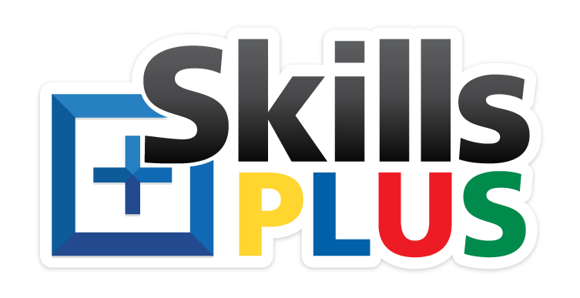
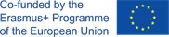

S K I L L S + P R O J E K T

EUROPEAN SKILLS COMPETITION FOR PEOPLE WITH A LABOUR DISSABILITY

Newsletter °2

SKILLS + PROJEKT:

We are now in preparation stage
WE are selecting a Skills+ coach from the organisations, assembling teams with participants for test assignments. Starting selecting teams and participants to represent the organisation at the National Skills+ Competition.

PALERMO MEETING
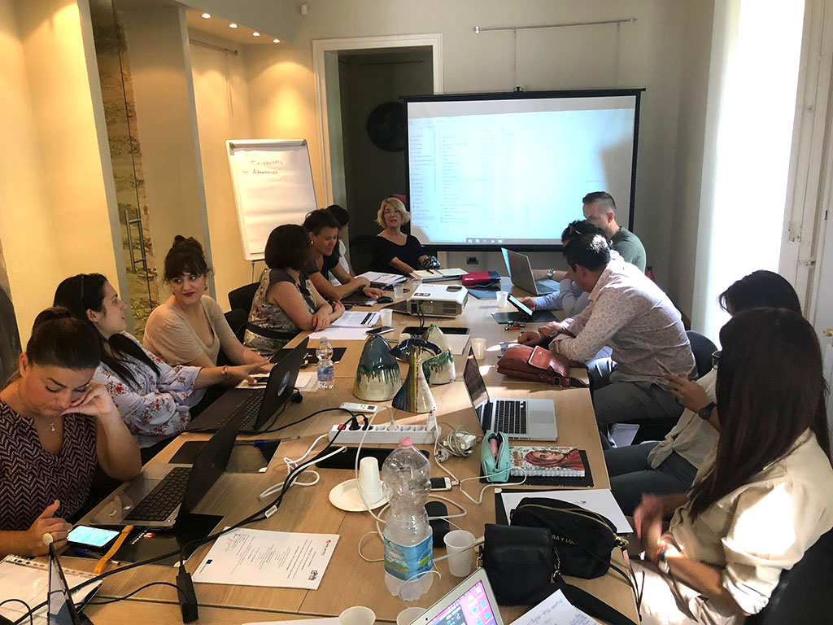
Second partners meeting took place on 18. September 2019 in Palermo, Italy. Partners discussed about the status of the project and what to do next! The Skills Plus competitions are competitions for teams and guarantee an unforgettable experience! Both individual and team skills play a part in the competitions and reflect the current situation on the labour market.

SKILLS+ VIDEO

We have a new video explaining what are Skills+ Competitions and how they work!

See more at http://www.skillsplus.eu/what-is-skills-plus/

https://youtu.be/wOn7UruFBuo

We started with 6 partners between 2014-2017. In 2018 we added five new full partners who will organise Skills+ Competitions for the first time in 2020. Belgium, Croatia, Greece, Spain and Turkey and five new partners with the status of observers, who will likely organise Skills+ Competitions in the future: Cyprus, France, Hungary, Portugal and Lithuania.

SKILLS+ COMPETITIONS HANDBOOK

Did you know that there is a detailed Handbook with everything you need to know about the concept and the organisation of National and European Competitions? We recommend it to organisations who wish to setup a Skills+ infrastructure and send a team to complete. You can download it from www.skillsplus.eu

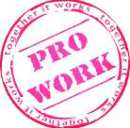
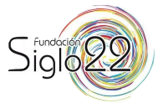
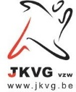
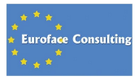
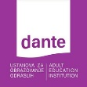
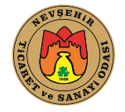

FOR MORE INFORMATION:
www.skillsplus.eu

